**National University of Computer & Emerging Sciences**

**Karachi Campus**



**Project Report**

**Object Oriented Programming**

**Section: J**

**[GEEKZILA]**

**Group Members:**

**19K-0249 Haris Aqeel**

**19K-0271 Ayesha Saif**

**19K-1326 Muhammad Jahanzeb**

# **INTRODUCTION:**

Project for the development of a user friendly console based application, named "GEEKZILA" designed for the feasibility of the user where the user can have access to three categories. First functionality is where the user can have an online conversation with other members available on the same network. Second functionality is where the user can have access to a library management system. And the third functionality where the user can have an access to the gaming arcade containing several games. It is a platform where the user can select among much functionality according to their requirement.

Every user will have a profile of their own that they will create when they start the program. In this order their library history will be safe, private and only for them to use. This console based application would provide the user with an educational resource i.e. library. It would also secure their online chat ID’s that only the user can access and also use that same ID to login in the gaming arcade. It will save the user from going through different applications for minor tasks as such.

# 1

# **WORKING:**

**Login panel** is created for the ease of the user where they can register for this console based application. We have a user class that is built for this specific login authentication and is shared throughout the project. Once the user has registered that ID it would allow the user to access all the functionalities of the application i.e. library management system, café management system, online chat, and gaming arcade. The login panel has all the necessary functions which are part of login authentication i.e. unique username, password encryption.

**Note:** The passwords of user are encrypted by a certain method before writing into the File and are decrypted while reading. (All code in LOGIN_PANEL.h and USER.h)

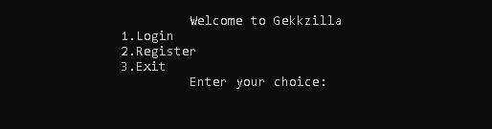

**Homepage** displays the functionalities of this console based application where the user would enter the choice according to the function they want to access.

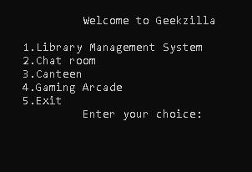

**Note:** There is a hidden Admin Panel on home page the admin needs to enter number **9** as the choice on the homepage and then provide admin password to access admin panel where they can modify users’ data or admins password.

(Current Admin pass: Ashii) All code is available in main.cpp and Admin_pannel.h

AD1

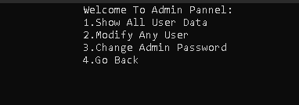

**Functionalities:  
l  
1. Library Management System:**

A system which allows the student to access the library through this console based application. It has the options of issuing the book, returning it, list of all the books available in the library and an administrator menu option. The user can access the books by entering the book number.

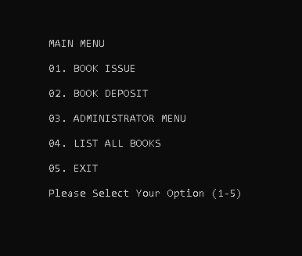

The options of library management system are further discussed in detail below.

* **Book Issue:** A student can issue the books that are available in the library by entering the roll number and the book number that the user wishes to issue. However, the user can have access to one issued book at a time.

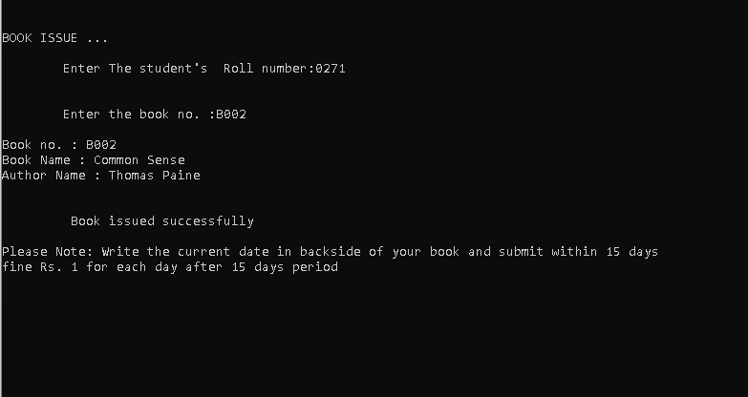

* 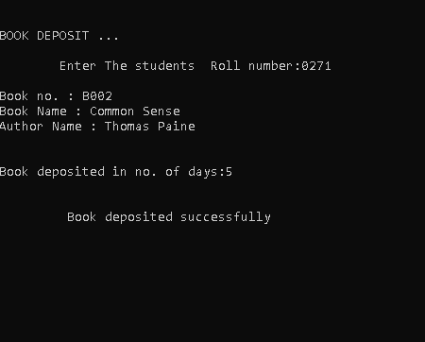**Book Deposit:**  The user can deposit back the book that was issued before. Once the user opt for this option the program would tell the user whether or not any book is issued under his roll number and then the program would ask for the duration of the issue if the book was issued for more than 15 days the user would get a fine of 10/_ per day.
* **Administrator Menu:** This menu is solely for the admin who can access the menu by entering the password (currently: haris). The purpose of this menu is to allow the administrator to create a new student record, display the records of all the students or records of any specific student the admin can modify or delete the record of the existing student(s), the admin can look for the record of all or any one specific book(s), they can also delete or modify the records of the books according to the availability of the books.

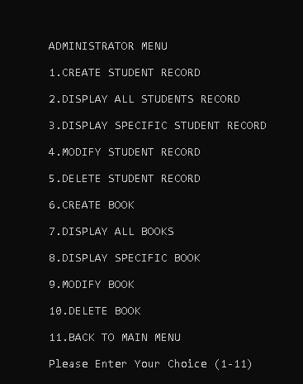

* 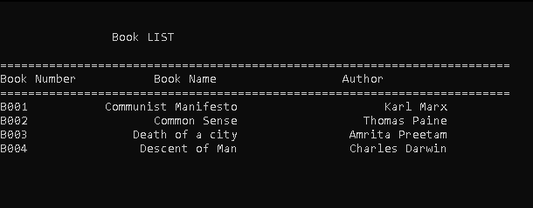**List All Books:** This option is for the user to check on all the books available in the library. This option would display all the books with their authors, book name, and book number.

1. **Chat system** is basically divided into two part .first is server side and another is client side. The chat system is a prototype and initially handle chat between two clients. It is expected that server is already running on the same network and both the clients are connected through the same network. The server holds the client 1 until the client 2 connects to server.

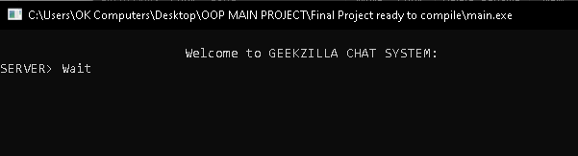

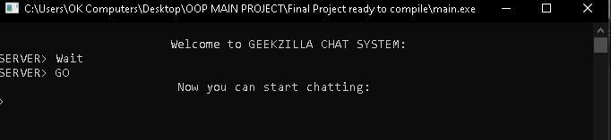 After the client 2 joins then the server lets the client1 to send a text message since we are working on single thread so both user have to wait for their turn to type message.

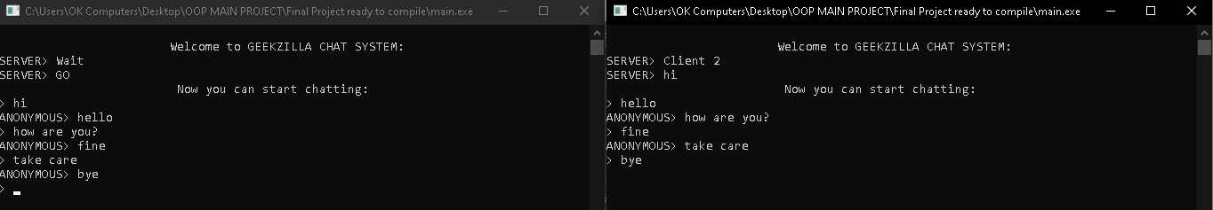

The server holds all the history of conversation between the clients at that time.

**(Extras: To leave the chat system just send an empty text)**

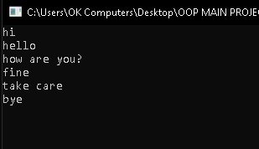

**3. Canteen** is part of the program that we designed the canteen for the feasibility of students so that they can order their food via this application.

We designed the canteen class so that it contains all the details regarding the items ordered by the students. So we can transfer the canteen object through socket to canteen server to have a copy of student order receipt with student credentials. Below we see the menu from which the students can chose from and place their orders:

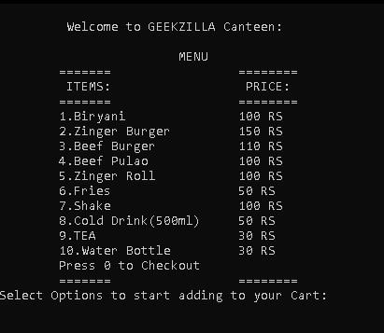

Once the order is placed the following receipt will be displayed which the student can show to the respective canteen to get their orders made.

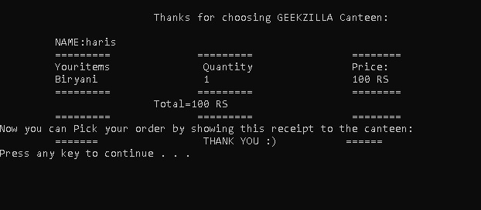

4. Finally the last thing that the GEEKZILLA consists of is the **Gaming Arcade**. The gaming arcade allows the user to choose between two games; “Snake” and “Pong” as shown below:



Pressing the number besides the name of the game will determine the user choice so if the user chooses “1”, they will be taken to the following menu:

1. **Snake :**

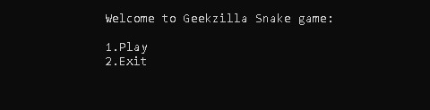

Once the user reaches this screen, they will have the ability to choose between the above two options. Choosing “2.Exit” will take them back to the main arcade screen whereas choosing “1.Play” will start the game and they will be taken to the following screen:



1. **Pong :**

Similar to the above process, if the user choses option “2.Pong Game”, they will be taken to the following screen:

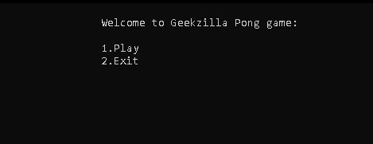

Again, following the same mechanics as in the case of the “Snake” game, the person is given two choices, whether to return to the main arcade menu (option “2.Exit”) or to proceed to the game (option “1.Play”), which would then bring us to the following screen :

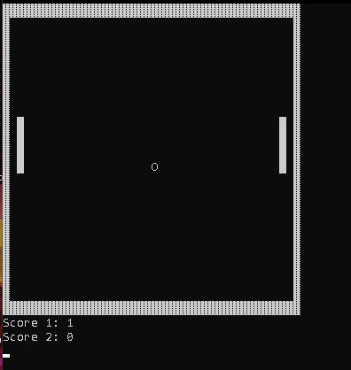

# **CONCLUSION:**

In conclusion this program can prove to be very useful for the user especially a student as it can help them avoid many unnecessary hurdles such as physically going to the canteen, waiting in line and finally placing their orders. Using this program, they can simply place their order from within any place on the campus. Additionally, the program provides a library management system where each student can keep those books which they particularly choose, hence creating a unique library from each student, and using the chat system, the students can share their books between each other and deal with queries that they might have in their studies with their teachers as well. The best thing about all of this however, is that a security measure can also be kept in place which could be assigned as a responsibility to the admin, as individual safety and security are a major area for concern when it comes to things like this. Speaking of safety and security, the program provides a strict user login and password authentication system so that no two individuals could have the same username, and no individual who has not yet registered as a member in the program could access it. They could even kill time by playing the games provided in the arcade. All in all, this program can be a very useful tool for the students, given that it is used properly.